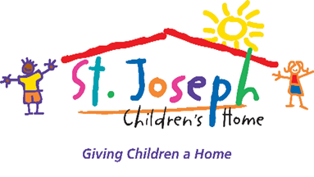
We will not quit until every child has a family

January 8, 2018, 2017
For immediate release:
St. Joseph Children’s Home announces appointment of Chris Whelan of LG&E and KU as incoming board president
Chris Whelan, LG&E and KU, appointed board president of St. Joseph Children’s Home
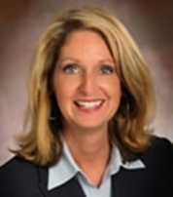 Chris Whelan, Vice President of Communications, LG&E and KU
Contact: Andrea Saylor, Development Director, 502.893.0241 or andreap@sjkids.org
The St. Joseph Children’s Home board of directors announced Monday the appointment of Chris Whelan as the president of the board, effective January 1, 2018. Whelan replaced Barbara Carter, former board president and current board member.
Whelan, vice president of Communications for LG&E and KU, has been a member of the St. Joe’s board of directors since 2014 serving in a variety of roles including chair of the annual St. Joe’s Picnic. She is currently the communications and development committee chair.
Whelan was promoted to her current role at LG&E and KU in May 2012 and has nearly 30 years of communications experience in the electric and natural gas industry. She currently oversees media relations, internal communications, branding, advertising, customer and digital communications, events, graphic design and web strategy as well as corporate responsibility and community affairs and the LG&E and KU Foundation.
She joined the utilities in 1995 and has held several leadership roles including a 15-month expat assignment at Powergen in the U.K. where she managed the brand and internal communications and new media functions. When E.ON AG announced plans to acquire Powergen, Whelan was promoted to manage merger communications strategies with the U.S., the U.K. and Germany. Upon her return to the U.S., she was named manager of Strategic, International and External Communications and served as the primary liaison for international communications activities and communications issues related to key business initiatives. She was promoted to director of Communications in 2007. She has a Bachelor of Arts degree in journalism with a concentration in history and political science.
Whelan was the 2013 chair of the Kentucky Derby Festival, after holding various leadership positions on the festival board. She is also vice president of the Kentucky Derby Museum board, an executive board member of Leadership Louisville, a board member of the Kentucky Derby Festival Foundation, and a member of the Fillies Inc., Utility Communicators International and a 2009 Bingham Fellows graduate.
Whelan joins current St. Joseph Children’s Home board members Brad Anderson, Matthew Brotzge, Barbara Carter, Lisa DeJaco Crutcher, Michael Ellis, Cheryl Fischer, Craig Harbsmeier, CPA, Kelly Henry, James A. Hillebrand, Dr. Richard McChane, M.D., Dr. Justin Miller, Ph.D., MSW, CSW, Sherlease Moppins, Paul Mullins, Tim Mulloy, Alex Rose, CPA, JD, William Schneider, and Dennis Withey. Grace Akers is the executive director, St. Joe’s has a staff of over 140.

St. Joseph Children’s Home recently announced a record 24 official adoptions for 2017.
St. Joseph Children’s Home hosts three programs: residential treatment, foster care and adoption and a child development center. For more information about these programs please visit: www.sjkids.org.

