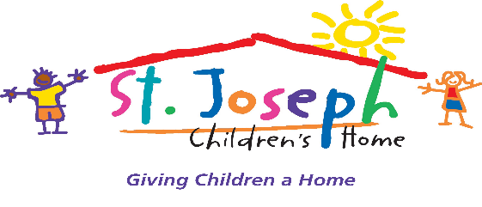

October 20, 2016
For immediate release:

Filmmaker Stu Pollard, Louisville Film Society shine light on the dire need to create families in St. Joe’s foster care; special viewing set for Hal & Ben’s Bike-In event Oct. 22
St. Joseph Children’s Home partners with the Louisville Film Society to create a film for children in foster care in Kentucky
Contact: Andrea Pridham, Development Director, 502.893.0241 or andreap@sjkids.org

The need to create families for children who have been removed from their homes is greater than ever before — especially in Kentucky. Record numbers of kids are being removed from their homes and placed into foster care; largely due to increased awareness and education throughout the country, stricter regulations in place for the safety of children, and epic spikes in substance abuse, mainly heroin, opioids and methamphetamine. Finding families for these children is more challenging because the substance abuse is often a family problem, not just of the parents. Many states are ill-equipped to deal with the demand for so many foster parents and families. The victims in this equation? Innocent children.
St. Joseph Children’s Home experiences this reality daily in their therapeutic foster care and adoption program which advocates at any given time for about 50 children from throughout Kentucky.
As a direct response to this problem, St. Joseph Children’s Home is releasing a promotional video that was created by local filmmaker Stu Pollard and members of the Louisville Film Society. The team collaborated in creating the video as a way to spread the message about children in need of foster care in Kentucky. The video features testimonials from children, foster parents, donors, and administrators, combining for a powerful message of tenacity, commitment, love and hope. It emphasizes the important work St. Joe’s does in the community, illustrates how desperately these children need new families, and spreads the word about abused and neglected children. The timing could not be better for kids in Kentucky.
Pollard, chair of the Louisville Film Society board, said “We were delighted to partner with St. Joe’s to help them tell their story, to get the word out to our community about the incredible work they do for so many children in need. LFS members Steve Saley, Brennan Clark, Nicole Teusch, Patrick Morris, and especially David Andreini all contributed to making this film. We hope this marks the first of many such collaborations between LFS and charitable organizations doing essential work in our community”

The short film will be available this week on St. Joe’s Facebook page and website. A public viewing will be held at Hal & Ben’s Bike-In at 8:30 p.m. October 22 at Finn’s Southern Kitchen, 1318 McHenry Street, Germantown, Louisville, Ky., . The event is free and for all ages, and partnered with Bicycling for Louisville, and the Louisville Film Society. The event, which gets underway at 5 p.m.., will feature live music from Otis Junior and the Jesse Lees, a set of all new music from Ben Sollee and Jordon Ellis from their record INFOWARS. The featured movie will be Nightmare before Christmas.

St. Joseph Children’s Home hosts three programs: residential treatment, foster care and adoption and a child development center. For more information about these programs please visit: www.sjkids.org.

